**SATISH PRADHAN DNYANASADHANA COLLEGE OF ARTS, SCIENCE AND COMMERCE, THANE**

*(Affiliated to University of Mumbai)*

**PROJECT REPORT**

On

**“Online Project Submission & Management System”**

Is submitted in partial fulfillment of

**T.Y.B. Sc (Computer Science)**

SUBMITTED BY

**Mr. Akash Santosh Katkar**

UNDER GUIDANCE OF

**Asst Prof. Pragati Ubale**



**Department of Computer Science**

**(2020-2021)**



**SATISH PRADHAN DNYANASADHANA COLLEGE OF ARTS, SCIENCE AND COMMERCE, THANE**

*(Affiliated to University of Mumbai)*

**(Department of Computer Science)**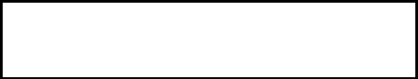

CERTIFICATE

Exam Seat No:

*This is to certify that Mr. Akash Santosh Katkar has successfully completed the project titled* ***“Online Project Submission & Management System”*** *and duly submitted the project in partial fulfillment of**the “T.Y.B. Sc (Computer Science)” degree from the University of Mumbai during the academic year 2020-2021. It is further certified that he has completed all the required phases of project.*

*________________ ________________*

Project Guide External Examiner

**Asst. Proff. Pragati Ubale**

*__________________ __________________*

Signature of HOD Signature of Principal

**Asst. Proff. Vaishali Gavandi**  **Dr. C. D. Marathe**

**DECLARATION BY THE STUDENT**

I, **Akash Santosh Katkar** student of B.Sc. (Computer Science) hereby

declare that the project for the Computer Science, **“Online Project Submission & Management** **System”** submitted by me for Semester-VI during the academic year 2019-20, is based on actual work carried out by me under the guidance and supervision of **Asst. Prof. Pragati Ubale.** I further state that this work is original and not submitted anywhere else for any examination.

**Signature of Student**

**EVALUATION CERTIFICATE**

This is to certify that the undersigned have assessed and evaluated the project on “, ***“Online Project Submission & Management System***” submitted by **Akash Santosh Katkar**, student of B. Sc (Computer Science).

This Project is original to the best of our knowledge and has accepted for Assessment.

**External Examiner**

**ACKNOWLEDGEMENT**

The project presented, as part of the curriculum, was the first experience of this kind for me. I had considered this project not only as a program of studies to be completed, but as a goal to learn, study, develop and test commercial software technologies.

I am pleased to be able to say that, in an acceptable manner, I have achieved my goals and goals to make this project a result. I would like to thank and thank the support of some who have helped physically, mentally and intellectually during this project.

Foremost regards to my guide **Asst. Prof. Pragati Ubale** I would thank our **H.O.D, Asst. Prof. Vaishali Gavandi, Principal, Dr. C.D. Marathe** who made available the facilities required for the project work.

I also want to mention the tacit support of my parents who, as always, helped me as much as possible to make my job a success. The contribution made by my friends and mates, directly or indirectly was indispensable, and will always be remembered. This opportunity has given me a valuable experience about Web Development.

With sincere regards,

***Akash Santosh Katkar***

**CONTENTS**

**Chapter 1: Introduction________________________________________8**

**1.1 Overview_________________________________________________ 8**

**1.2 Description of The Current System___________________________ 8**

**1.3 Limitations Of Current System______________________________ 8**

**1.4 Objective of the project____________________________________ 9**

**1.5 Description of Proposed system______________________________9**

**1.6 Advantages of Proposed System_____________________________ 9**

**Chapter 2 System Analysis_____________________________________ 15**

**2.1 Feasibility Study___________________________________________15**

**2.1.1 Operational feasibility_____________________________________15**

**2.1.2 Technical feasibility_______________________________________15**

**2.1.3 Financial and Economic feasibility__________________________ 16**

**2.1.4 Handling Infeasible Projects_______________________________ 16**

**2.2 Requirement Analysis______________________________________ 17**

**2.2.1 Functional Requirements__________________________________ 17**

**2.2.2 Non Functional Requirements______________________________ 17**

**2.2.3 Performance Requirements_________________________________19**

**2.2.4 Hardware & Software Requirements_________________________19**

**Chapter 3 Data Flow Diagrams________________________________39**

**3.1** **Level 0 (Context Level) DFD___________________________40**

**3.2** **Level 1 DFD___________________________________________41**

**3.3** **Level 2 DFD For Student________________________________42**

**3.4** **Level 2 DFD For Teacher________________________________43**

**3.5** **Level 2 DFD For Admin_________________________________44**

**Chapter 4 System Design____________________________________ 45**

**4.1 Entity-Relationship Diagram______________________________ 47**

**4.2 Class Diagram__________________________________________ 47**

**4.3 Usecase Diagram________________________________________ 48**

**4.4 Sequence Diagram_______________________________________ 50**

**4.5 Component Diagram_____________________________________ 50**

**4.6 State Diagram___________________________________________ 50**

**4.7 Package Diagram________________________________________ 50**

**4.8 Deployment Diagram_____________________________________ 50**

**4.9 Data dictionary__________________________________________ 53**

**Chapter 5 Testing___________________________________________ 61**

**Chapter 6 Future Enhancement_______________________________ 67**

**Chapter 7 Result____________________________________________ 61**

**Chapter 8 Conclusion________________________________________68**

**Chapter 9 Bibliography_______________________________________69**

***Online Project Submission***

***&***

***Management System***

**Chapter 1: INTRODUCTION**

**1.1 Overview:**

The overall view of the project can be explained as the project submission and the corrections. The website is a management system and the website manage the student’s project in their database. Basically, the website is used to upload the project of a student parts-by-parts classified by the teachers manually. The student actually has to login to the website and create a project of their chosen topic. Then the student is taken to the stages Session where the project will be divided into parts to upload based on the topic. The student & teacher can also update and modify their account details accordingly. As the give a motive and an introduction of the existence of the site, we are also providing with “About Us” session .The student account is given with ”Contact” page where the student can access the teacher’s and college faculty contact details for verifying any doubts or queries manually if arises. In the admin module the system administrator of the college will have the entire rights to remove & add teacher and also edit the details of the respective teacher as well as student.

**1.2 Description of The Current System:**

* The current system needs high amount of human work to process the projects submitted by the students.
* Also the current system needs human interaction to create groups of teachers and students.
* The teachers can accept and reject the projects from anywhere and anytime unlike the current system the teacher needs to be physically present in college to evaluate the project.

**1.3 Limitations Of Current System:**

The limitations of current system:

* Time consuming
* Data Loss May Occur
* Paperwork Required

**1.4 Objective of the project:**

* To provide an online environment where students and teachers can interact regarding the projects submitted by the student.
* The students can submit the project from anywhere without much efforts.
* To make the projects made by students available to the students by allowing them to download the project.
* To reduce the paper work and provide a step by step approach for submitting the projects by made students.

**1.5 Description of Proposed system:**

* The proposed system can overcome all the problems of the current system.
* In the proposed system the user will just need to login by setting up the credentials from the link provided in the official mail id.
* Once the Account setup is completed the student can upload the project if the idea gets accepted by

the respective group teacher.

**1.6 Advantages of Proposed System:**

* Reduced Time Consumption
* Prevents Data Loss

**Chapter 2: System Analysis**

**2.1 Feasibility Study:**

Feasibility Study is a preliminary study undertaken to determine and document a project's viability. The term feasibility study is also used to refer to the resulting document. These results of this study are used to make a decision whether to proceed with the project, or table it. If it indeed leads to a project being approved, it will — before the real work of the proposed project starts — be used to ascertain the likelihood of the project's success. It is an analysis of possible alternative solutions to a problem and a recommendation on the best alternative. For Example, can decide whether an order processing be carried out by a new system more efficiently than the previous one.

**2.1.1 Operational feasibility:**

It is to find out whether the current work practices and procedures support a new system. Also social factors i.e. how the faculty changes will affect the working lives of those affected by the system.

**2.1.2 Technical feasibility:**

This involves questions such as whether the technology needed for the system exists, how difficult it will be to build, and whether the firm has enough experience using that technology. The assessment is based on an outline design of system requirements in terms of Input, Processes, Output, Fields, Programs, and Procedures. This can be qualified in terms of volumes of data, trends, frequency of updating in order to give an introduction to the technical system. The application is the fact that it has been developed on Windows 7 platform and a high configuration of 2GB RAM on Intel Pentium dual core processor. This is technically feasible.

**2.1.3 Financial and Economic feasibility:**

Establishing the cost-effectiveness of the proposed system i.e. if the benefits do not outweigh the costs then it is not worth going ahead. In the fast paced world today there is a great need of online social networking facilities. Thus the benefits of this project in the current scenario make it economically feasible.

**2.1.4 Handling Infeasible Projects:**

We did not face any infeasibility during this project because we used Sublime 3.2.2 to build this project. We installed it in laptop easily because it is available free of cost. Whenever we got errors or difficulties in project, our project guide helped and provided the way to proceed. We completed project before deadline successfully.

**2.2 Requirement Analysis:**

We are overcoming the difficulty of generating a blackbook which is a manual process in the current system and here we store the blackbook generated by the students in a stage by approach.

**2.2.1 Functional Requirements:**

This section describes the functional requirements of the system for those requirements which are expressed in the natural language style. Admin has the responsibility of assign group id’s to the teachers and ensure that all the student in the college database have been assign group id’s. There are two stages out of which in the first stage a supervisor has to examine whether the project topics have been repeated. Now once the supervisor has accepted the project the project topic will be forwarded to the respective group leader/teacher. Now the teacher will have will be responsible for accepting/rejecting the project documentation.

**2.2.2 Non Functional Requirements:**

**Usability**

* This section includes all of those requirements that effect usability.
* We get the response within seconds.
* The software must have a simple, user-friendly interface so customers can save time and confusion.

**Reliability**

* The system is more reliable because of the qualities that are inherited from the chosen platform php. The code built by using php is more reliable.

**Implementation**

* The system is implemented in web environment. The wampserver is used as the web server and windows 7 Home is used as the platform.

**Interface**

* The user interface is based on the web browser. The application is developed using CSS and HTML.
* The Interface design is aimed at a flexible front-end communication to provide the user with clear information in navigating a user-friendly interface is planned.

**2.2.3 Performance Requirements:**

* The completely separate business logic at server side from the student interface ensures good performance.
* The system exhibits high performance because it is well optimized. The business logic is clearly separate from the UI.
* We get the response within seconds.

**2.2.4 Hardware & Software Requirements:**

**Software Requirement:**

* Operating System – Microsoft Windows 2010
* Application Software –
* Front end: HTML, CSS,JS,JQUERY
* Back end: PHP, SQL

**Hardware Requirement:**

* Processor - 1.6 GHz
* RAM - 4GB or more
* Disk Space – 3 GB or les

**Chapter 3: Data Flow Diagrams**

**3.1 Level 0 (Context Level) DFD:**

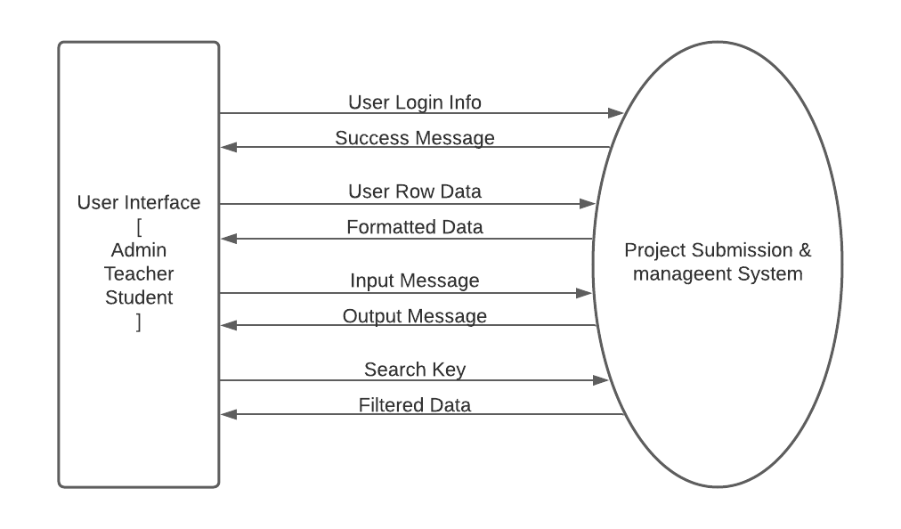

**3.2 Level 1 DFD:**

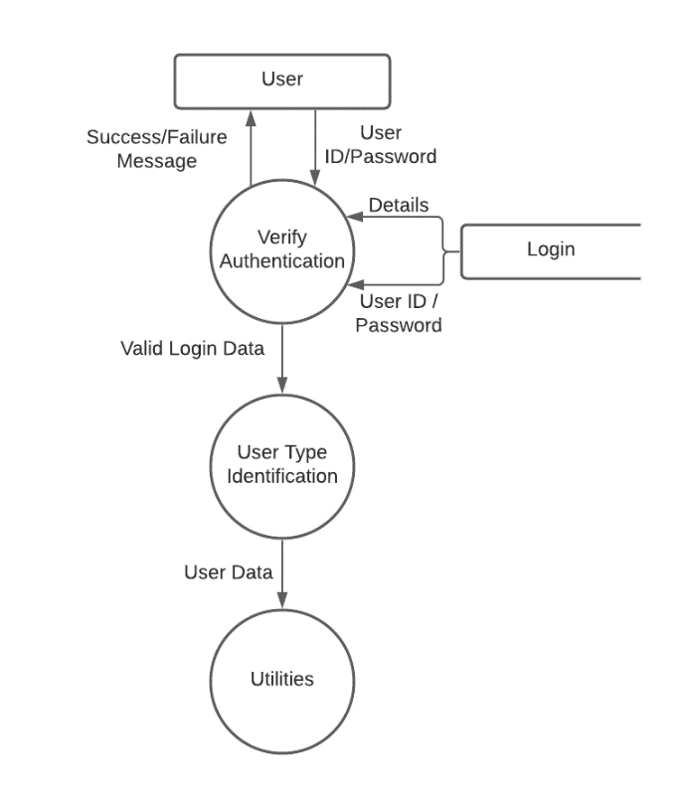

**3.3 Level 2 DFD For Student:**

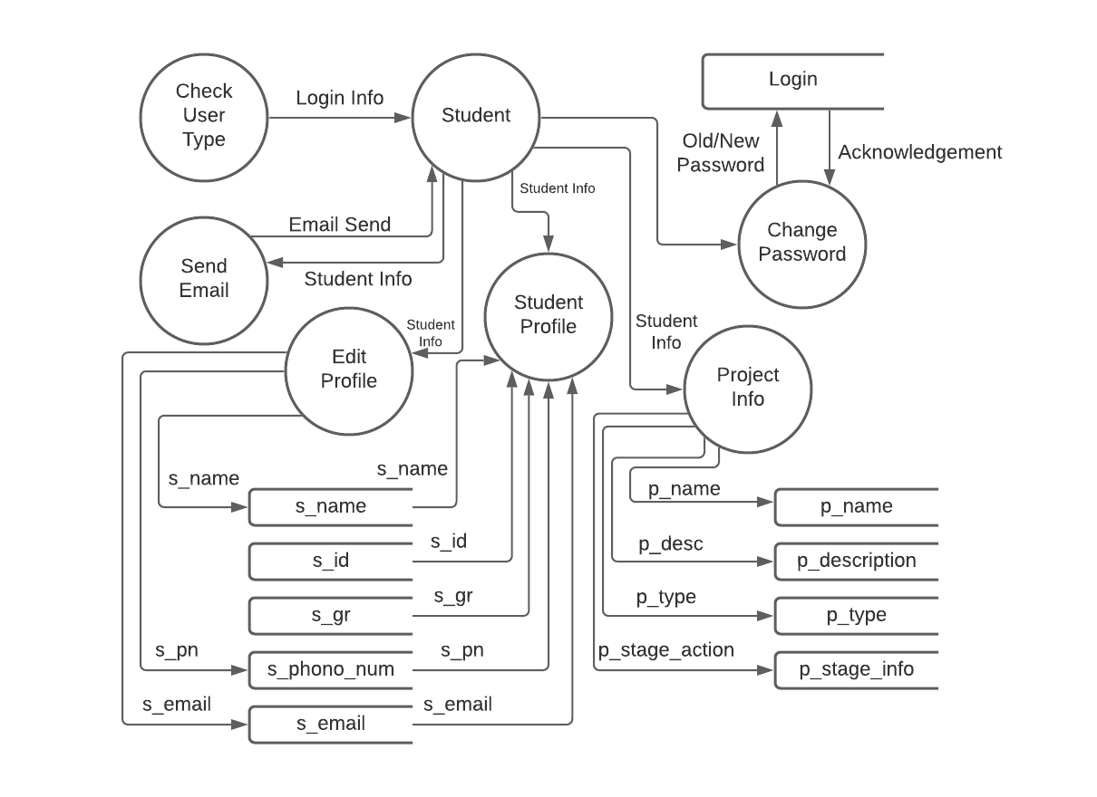

**3.4 Level 2 DFD For Teacher:**

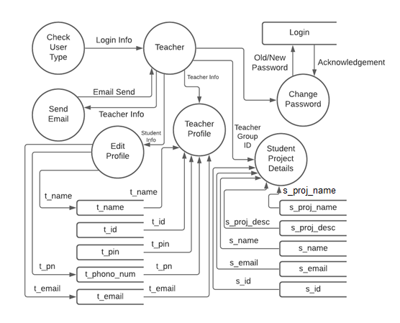

**3.2 Level 2 DFD For Admin:**

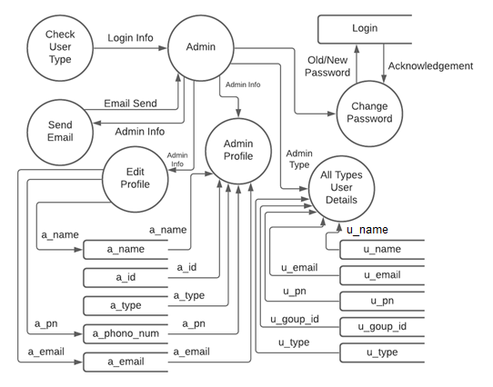

**Chapter 4: System Design**

**4.1 Entity-Relationship Diagram:**

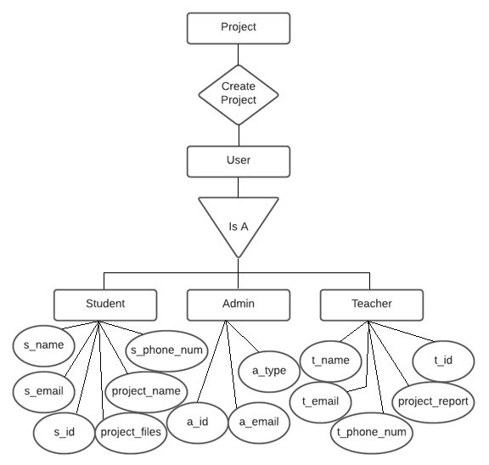

**4.2 Class Diagram:**

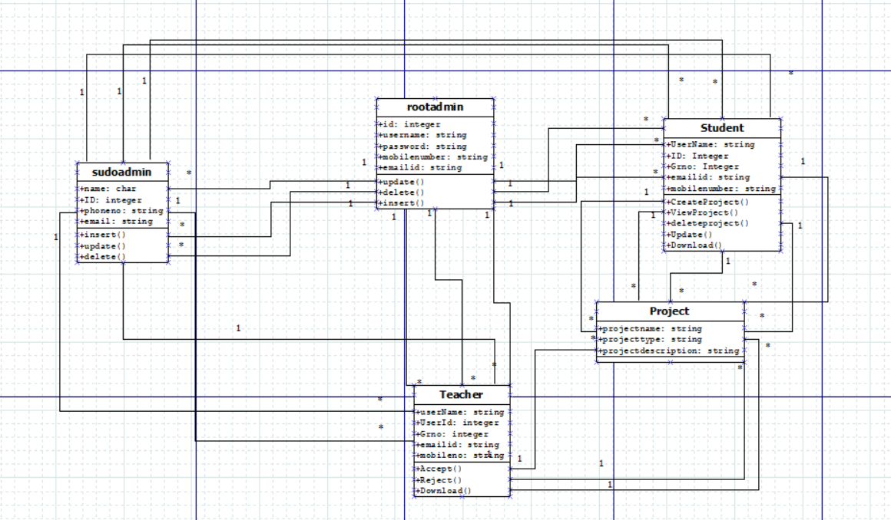

**4.3 Usecase Diagram:**

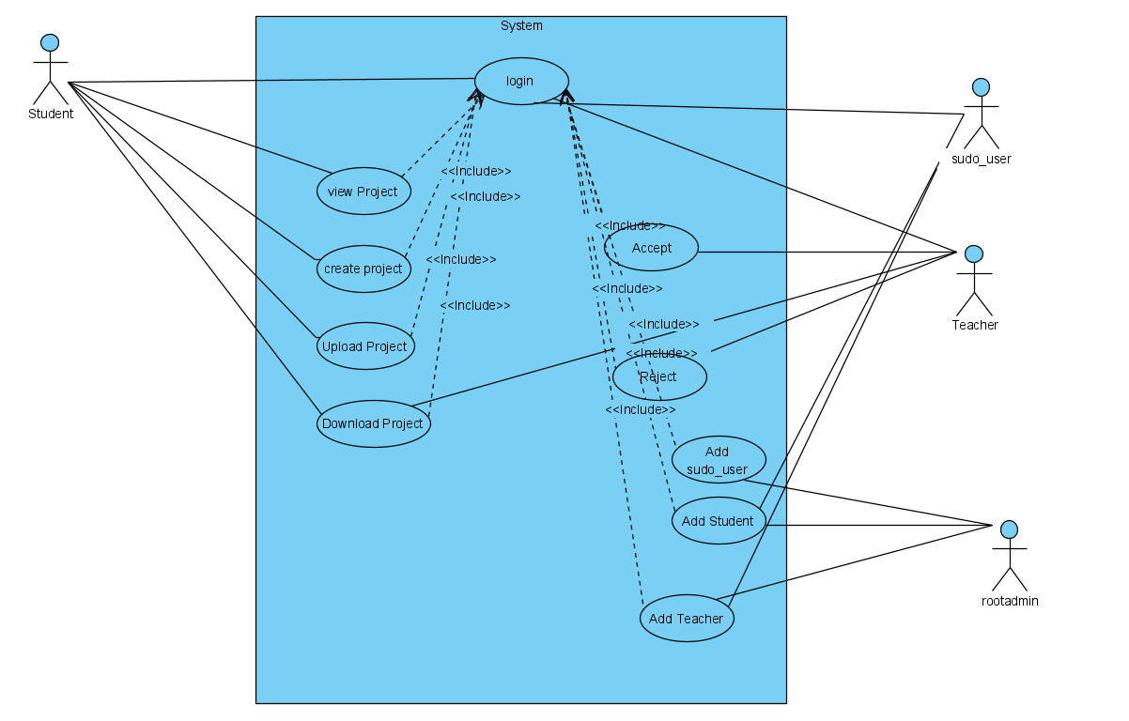

**4.4 Sequence Diagram:**

**4.4.1 Admin**

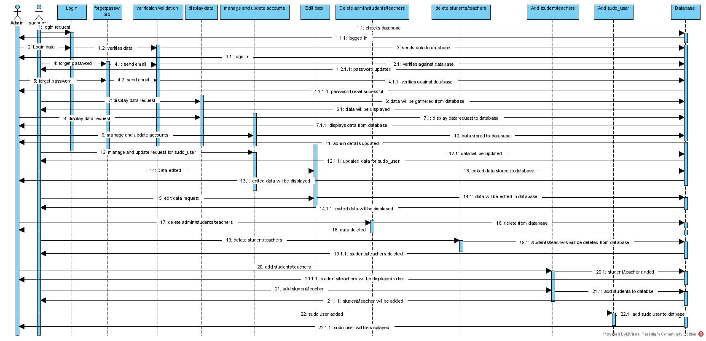

**4.4.2Teacher:**

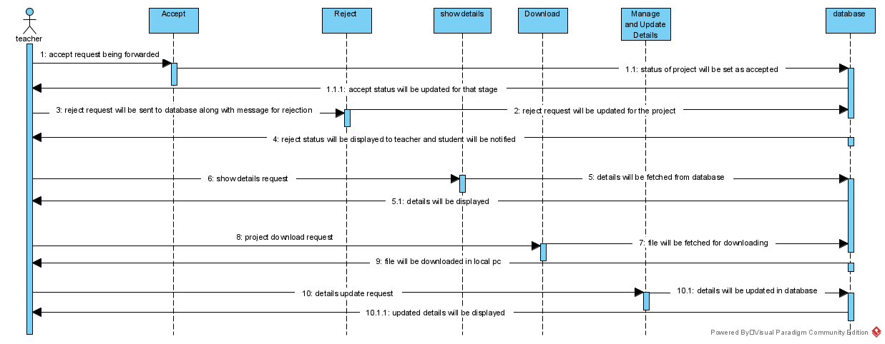

**4.4.3Student:**

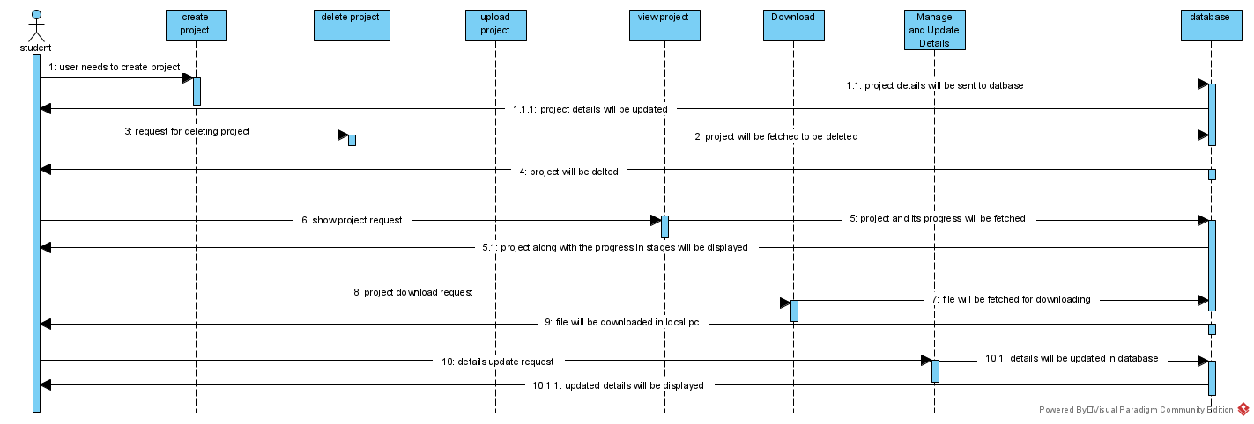

**4.5 Component Diagram:**

**4.5.1 Student :**

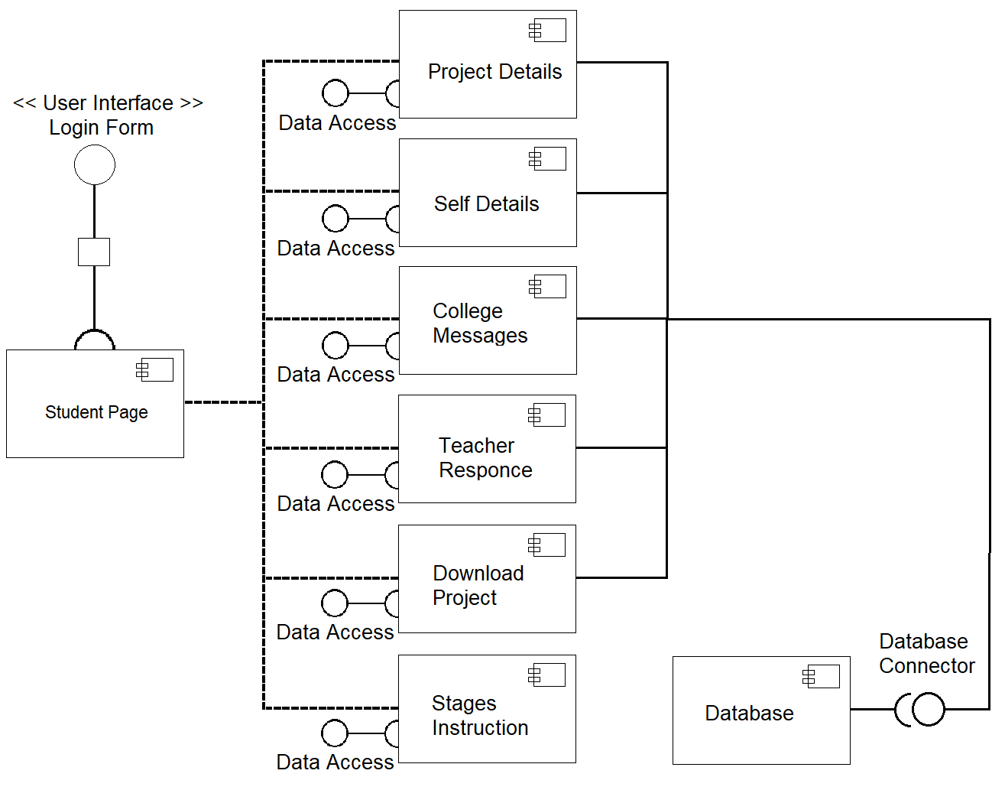

**4.5.2 Teacher:**

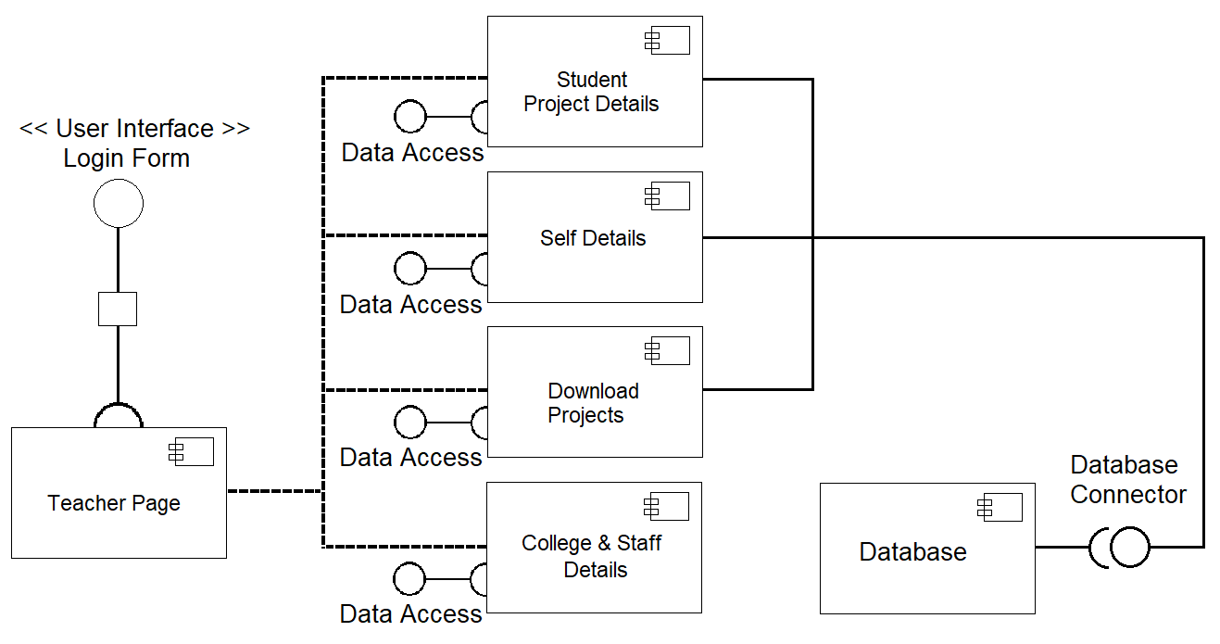

**4.5.3 Admin:**

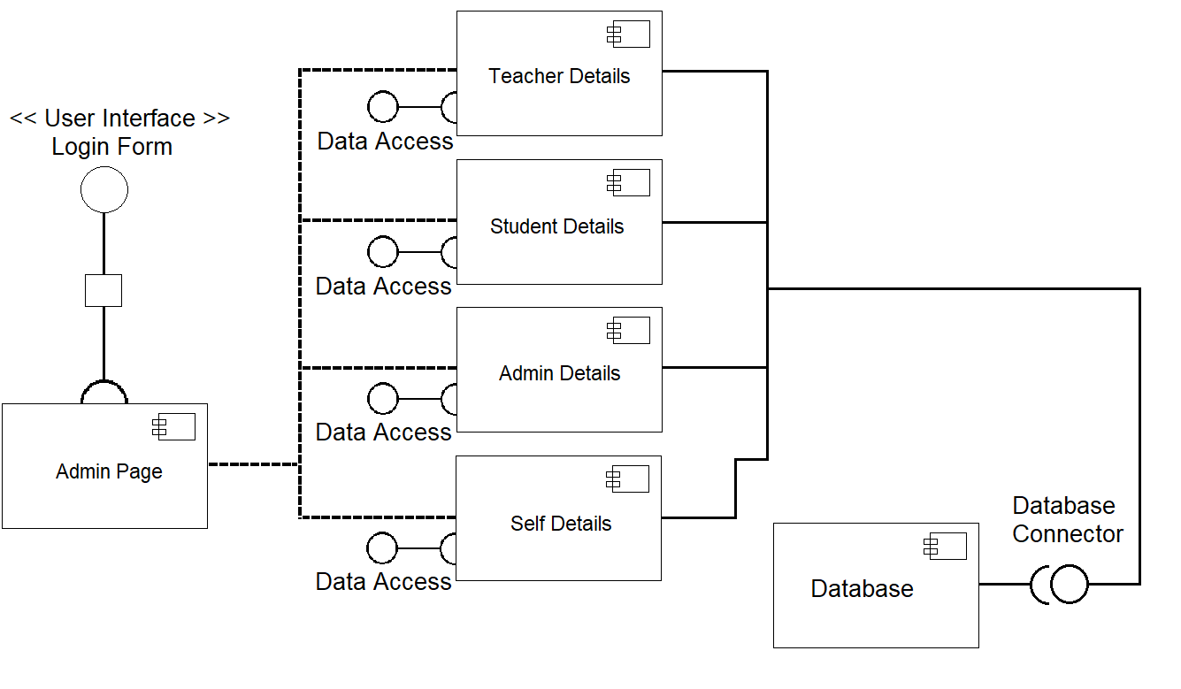

**4.6 State Diagram:**

**4.6.1 Student :**

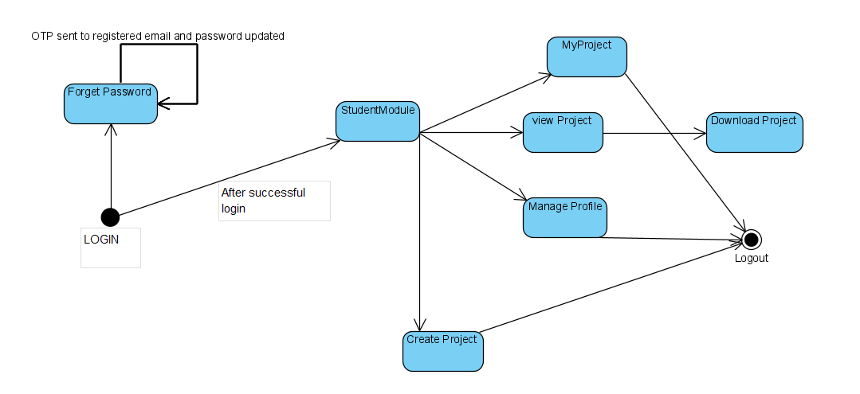

**4.6.2 Teacher:**

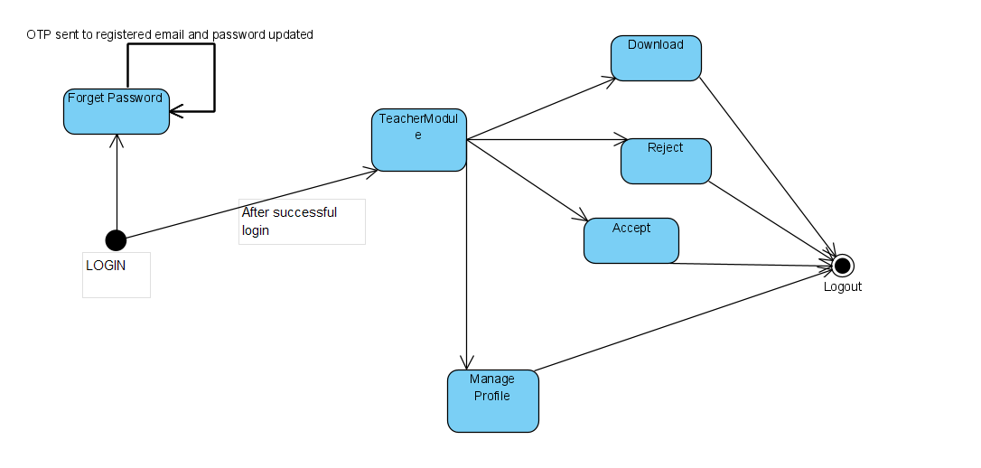

**4.6.3 Admin:**

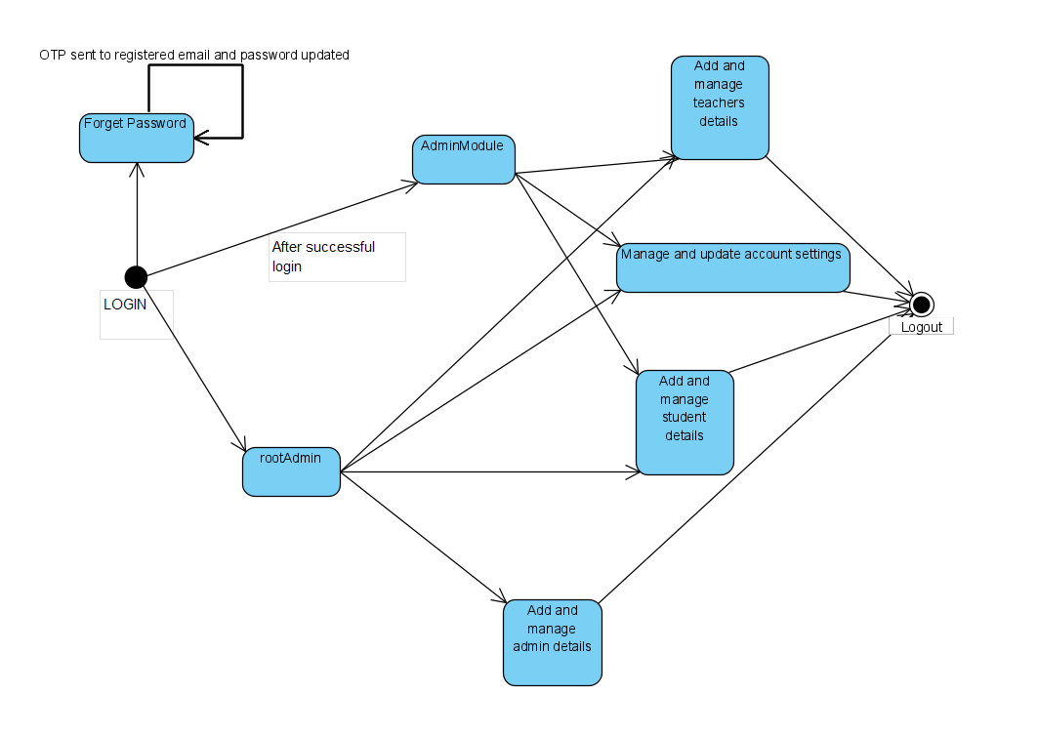

**4.7 Package Diagram:**

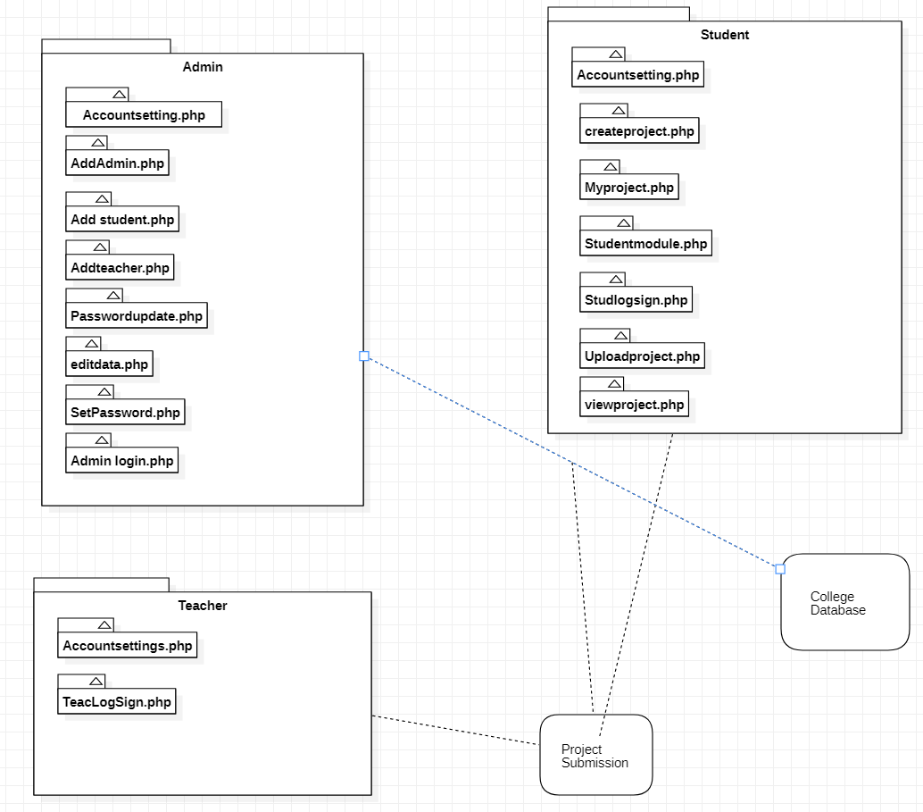

**4.8 Deployment Diagram:**

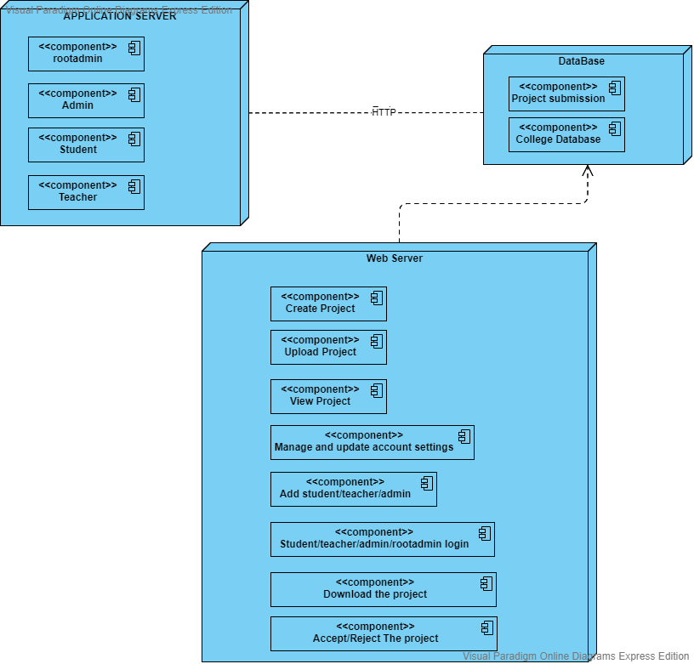

**4.9 Data dictionary:**

**college_database.stud_table**

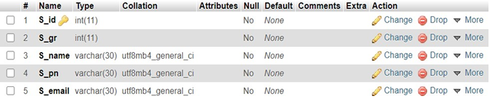

**Table 4.9.1:College_database.Student**

**college_database.teac_table**

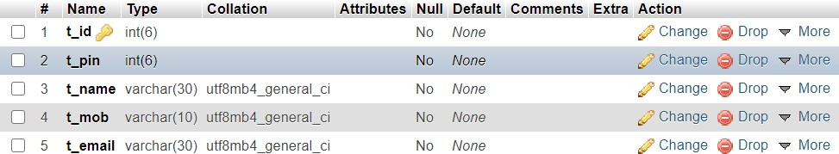

**Table 4.9.2:College_database.Teacher**

**projectsubmission.admin**

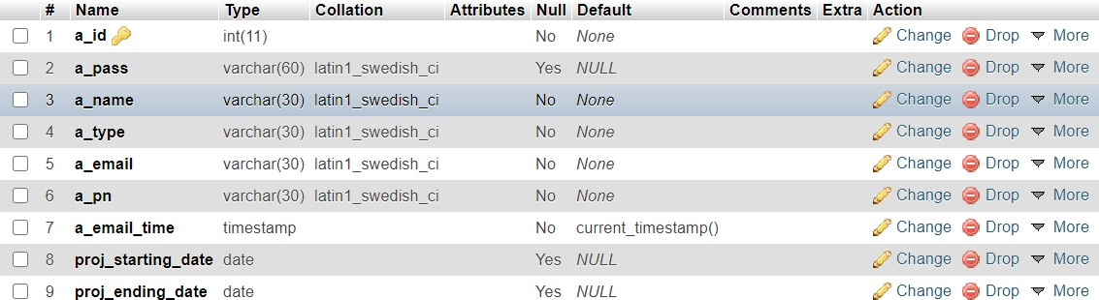

**Table 4.9.3:ProjectSubmission.Admin**

**projectsubmission.project**



**Table 4.9.4ProjectSubmission.Project**

**projectsubmission.** **queries_doubts**

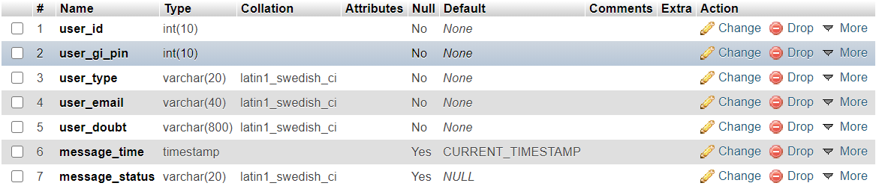

**Table 4.9.5:ProjectSubmission.queries_table**

**projectsubmission.rejected_proj_table**

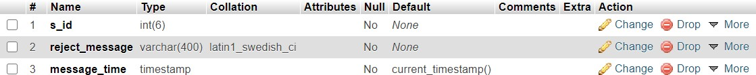

**Table 5.9.6:ProjectSubmission.rejected_table**

**projectsubmission.student**

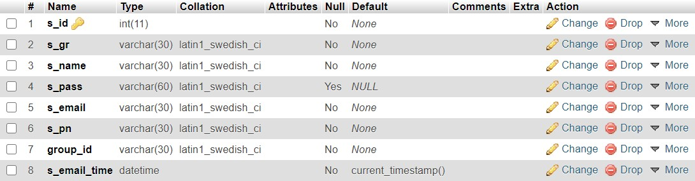

**Table 4.9.7:ProjectSubmission.Student**

**projectsubmission.teacher**

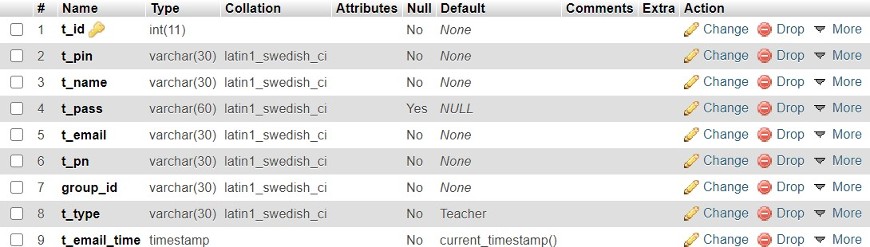

**Table 4.9.8:ProjectSubmission.teacher**

**Chapter 5: Testing**

Testing is the stage of implementation, which is aimed at ensuring that the system works accurately and efficiently before live operation commences. The logical design and physical design is thoroughly and continually examined on paper to ensure that they will work when implemented.

Thus the system test in implementation was a confirmation that all is correct and an opportunity to show the users that the system works.

Testing of the online classified system was performed in three stages which are as follows :-

* Unit Testing
* Integration Testing
* System Testing

1. **Unit Testing:**

Unit testing is under taken when a module has been coded and successfully reviewed. This can be done by two methods:

**a) Black Box Testing**

Test cases are designed from an examination of the input/output values only and no knowledge of designing or coding is required the following are the two main approaches of designing black-box test cases.

**b) Equivalence Class Partitioning**

The domain of input values to a program is partitioned into a set of equivalence classes. This partitioning is done on such way that the behavior of the program is similar to every boundary value analysis. Boundary value analysis leads to selection of the test cases at the boundaries of different equivalence classes.

Testing done by : Team Member

In our project particularly, first we create the login form & then by running the form we conclude & tested that whether it runs properly or not. So such a way we perform the Unit Testing & in this way we have done the testing to all the forms.

1. **Integration Testing:**

During integration testing different modules of the system are integrated using integration plan. The integration plan specifies the steps and the order in which modules are combined to realize the full system.

Purpose:

* To test whether the module performs its intended task.
* Once all the modules have been integrated and tested, system testing can start.

In this project the Login module, Edit student & teacher, List of all module a were integrated & tested that the system is running properly or not. Thus with the following way we performed Integration Testing.

1. **System Testing:**

**System Testing** is performed on a complete integrated system to evaluate the compliance of the system with the corresponding requirements.

In system testing, integration testing passed components are taken as input. The goal of integration testing is to detect any irregularity between the units that are integrated together. System testing detects defects within both the integrated units and the whole system. The result of system testing is the observed behavior of a component or a system when it is tested.

**Alpha Testing:**

* The initial testing of a computer program or system under actual usage conditions, it can be done in-house by the vendor, or outside by a customer or third party teaser.
* Acceptance Testing performed by the customer in a controlled environment at the developer‘s site. The software used by the customer in a setting approximating the target environment with the developer observing and recording errors and usage problems.

**Beta Testing :**

Beta Testing is done after alpha testing. The main purpose of Beta Testing are as follows:-

* Testing done by the potential or existing users, customers and end users at the external site without developers involvement is known as beta testing.
* It is operation testing i.e. it tests if the software satisfies the business or operational needs of the customers and end users.
* Beta Testing is done for external acceptance testing of COTS(Commercial off-the-shelf) software.

**Different Methods of Testing :**

**White Box Testing :**

White-box testing is a methodology used to ensure and validate the internal framework, mechanisms, objects and components of a software application. White-box testing verifies code according to design specifications and uncovers application vulnerabilities.

White-box testing is also known as transparent box testing, clear box testing, structural testing and glass box testing. Glass box and clear box indicate that internal mechanisms are visible to a software engineering team.

White-box testing advantages include:

* Enables test case reusability and delivers greater stability.
* Facilitates code optimization.
* Facilitates finding of the locations of hidden errors in early phases of development.
* Facilitates effective application testing.
* Removes unnecessary lines of code.

**Regression Testing :**

It is a type of software testing i.e. carried out by software testers as functional regression tests & developers as Unit Regression Tests. Objective of regression tests are to find defects that got introduced to detect fixes or introduction of new features. Regression tests are ideal candidate for automation.

**Accessibility Testing :**

This is a formal type of software testing that helps to determine whether the software can be used by people with disability. There are also companies & consultants that provide website accessibility audits.

**Ad-hoc Testing :**

Ad hoc testing is an informal and improvisational approach to assessing the viability of a product.

An ad-hoc is usually only conducted once unless a defect is found.

Commonly used in software development, ad hoc testing is performed without a plan of action and any actions taken are not typically documented. Testers may not have detailed knowledge of product requirements. Ad hoc testing is also referred to as random testing and monkey testing.

**Validation :**

* User id & password cannot be blank while logging into the site.
* In the edit profile page or the new user account page there are some mandatory fields like login id, password, name, gi no., project name, project all files etc. which cannot be left blank.
* In the modify password page user have to specify the login id as well as the old password & the new password.
* In the email id field @. characters are mandator.

**MAINTENANCE**

Maintenance of a typical software product requires much more effort than the effort necessary to develop the product itself. The relative effort of development of a typical software product to its maintenance effort is roughly in the 40:60 ratios. Maintenance involves performing any one or more of the following three kinds of activities:

* Correcting errors that were not discovered during the product development phase. This is called “Corrective Maintenance”.
* Improving the implementation of the system, and enhancing the functionalities of the system according to the customer‘s requirements. This is called “Perfective maintenance”.
* Porting the software to work in a new environment. For example, porting may be required to get the software to work on a new computer platform or with a new operating system. This is called “Adaptive Maintenance”.

**Chapter 6: Future Enhancement**

* + - In Future a chat application may be integrated into this website through which students and teachers can communicate with each other.
    - In the future the user (student/teacher) can preview the file before downloading/uploading the files .
    - In the future a well defined report system will be introduced through which users can report any malicious activity /action.In return the student will get a ticket that will be identified by its unique ticket number.
    - Through the ticket the user will get to know about the admin details as admin name who will be managing the issues posted by the user and the user will get a live tracking of the issue being resolved.

**Chapter 7: Result**

**7.1 ScreenShots:**

**7.1.1 Login Page:**

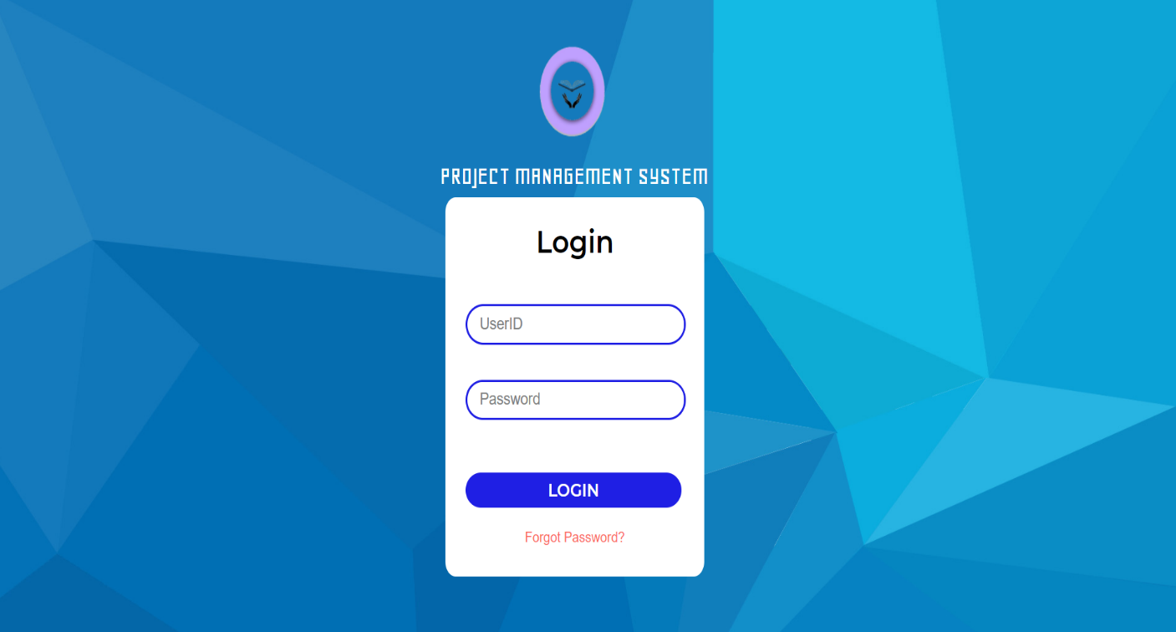

**7.1.2 Admin DashBoard:**

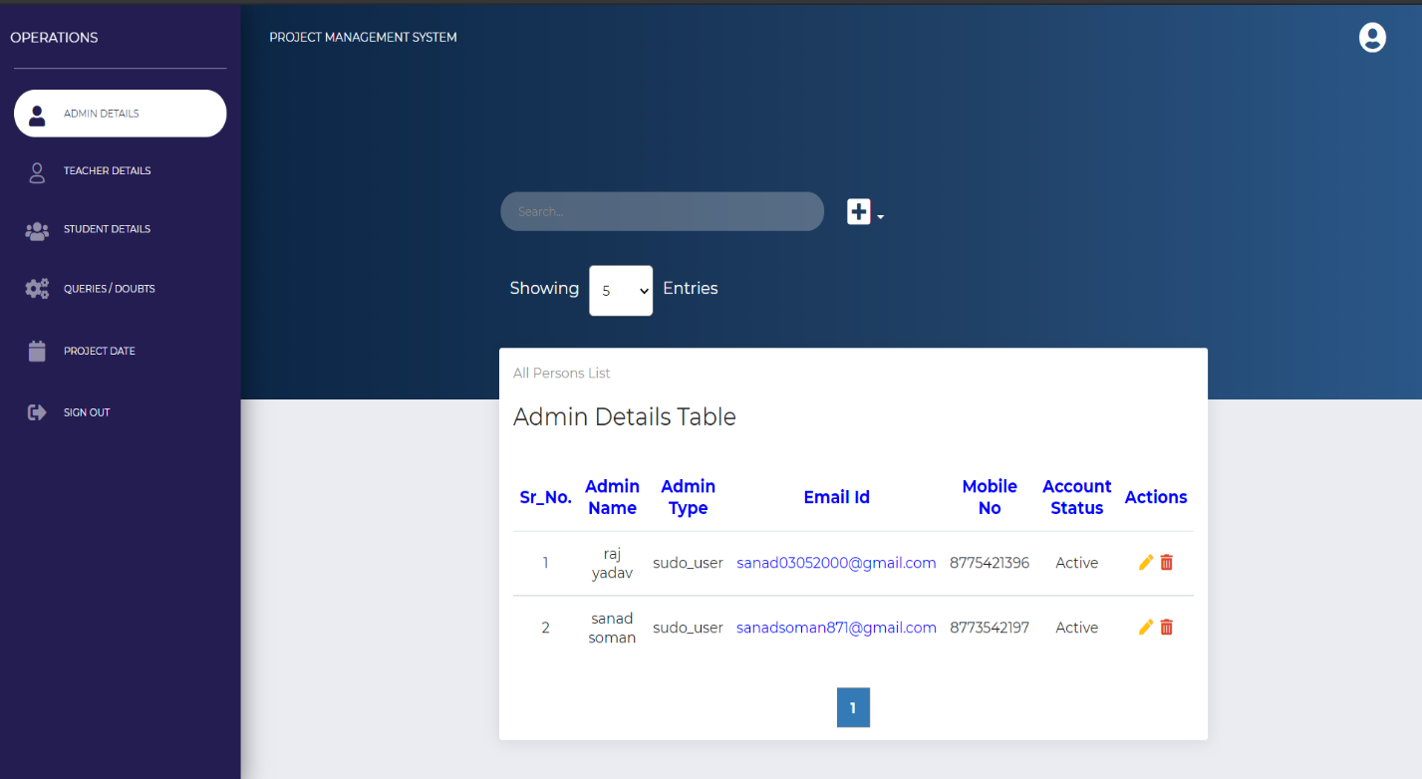

**7.1.3 Teacher Details:**

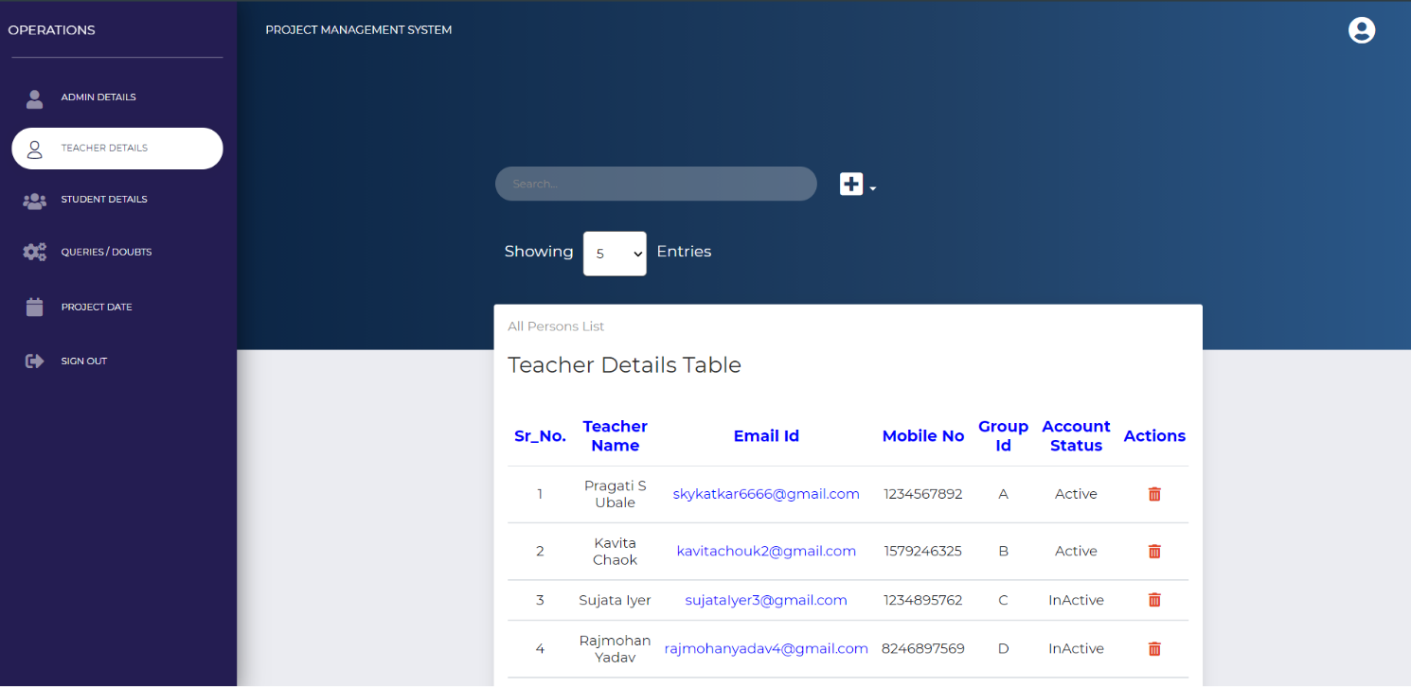

**7.1.4 Student Details:**

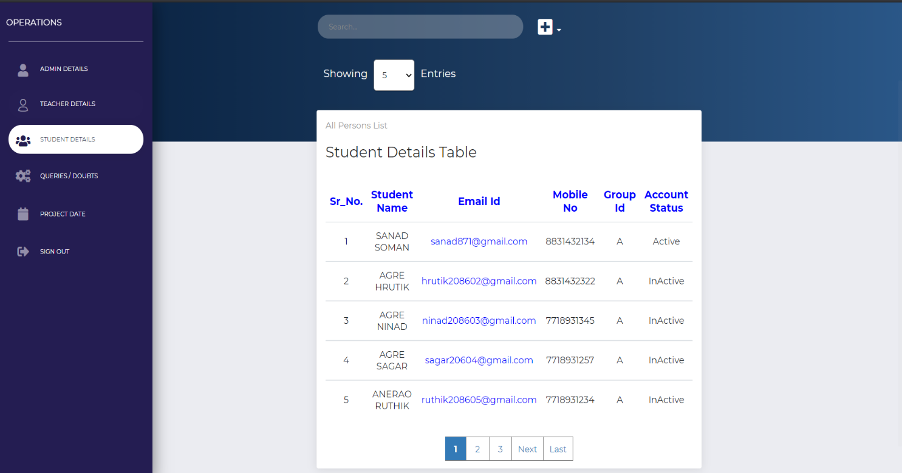

**7.1.5 Project Starting And Ending Date:**

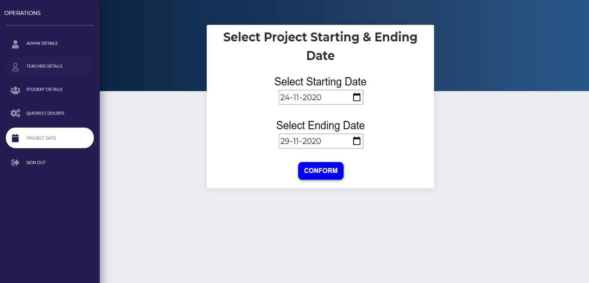

**7.1.6 Details:**

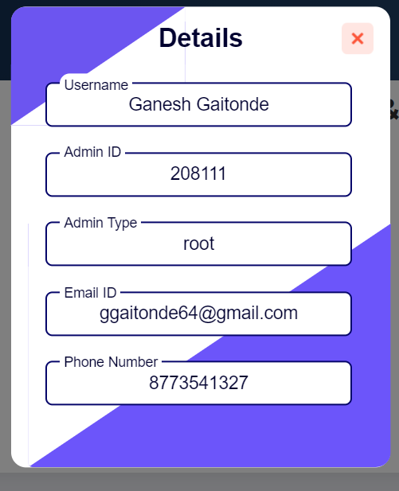

**7.1.7 Main page:**

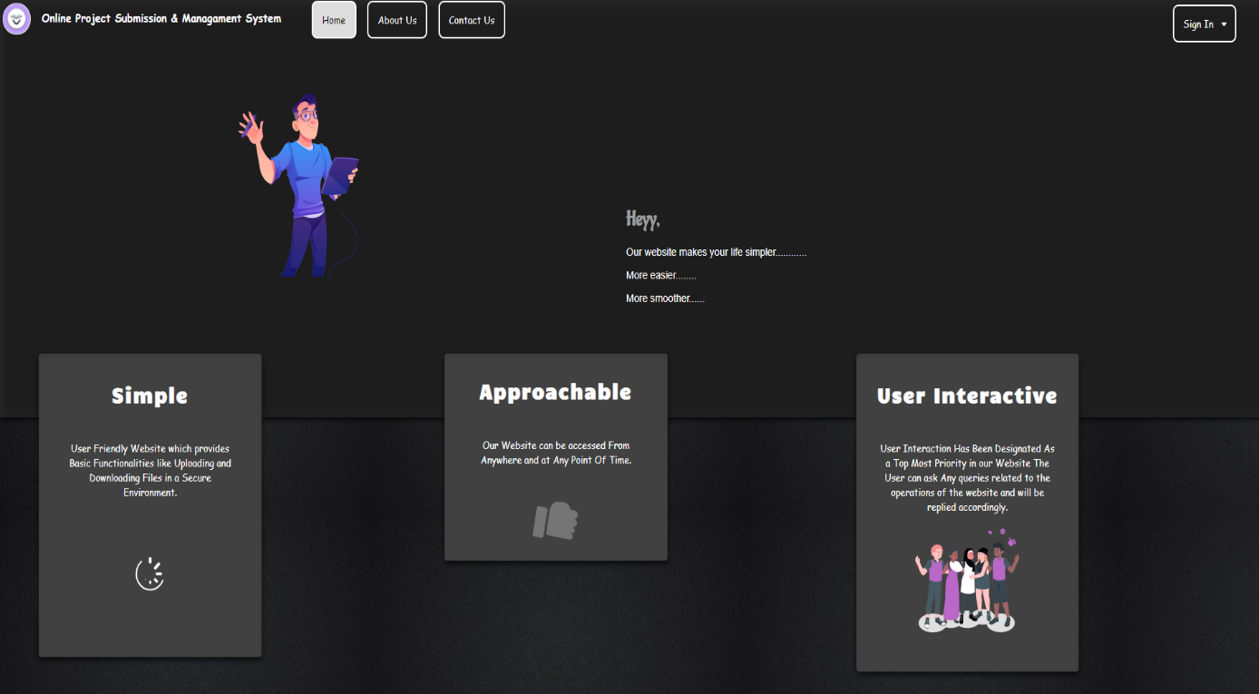

**7.1.8 Account Settings:**

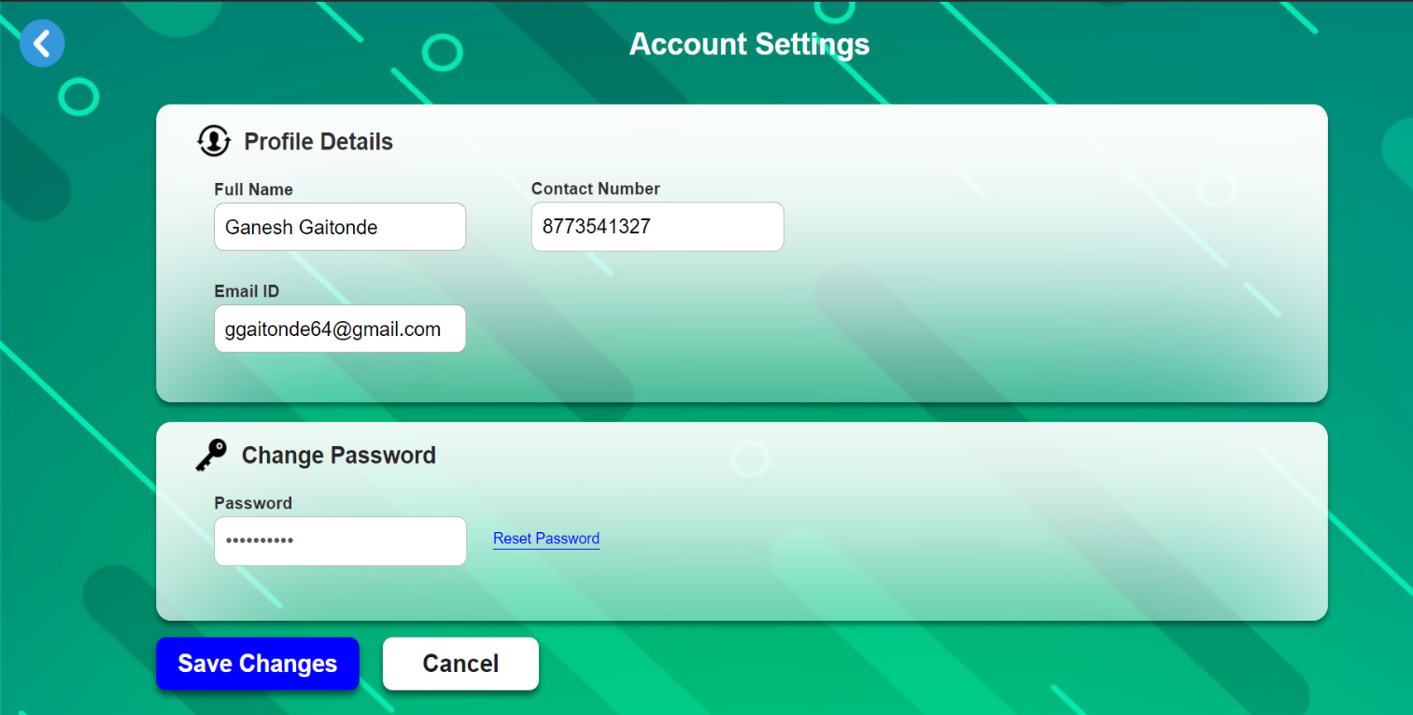

**7.1.9 Student Module:**

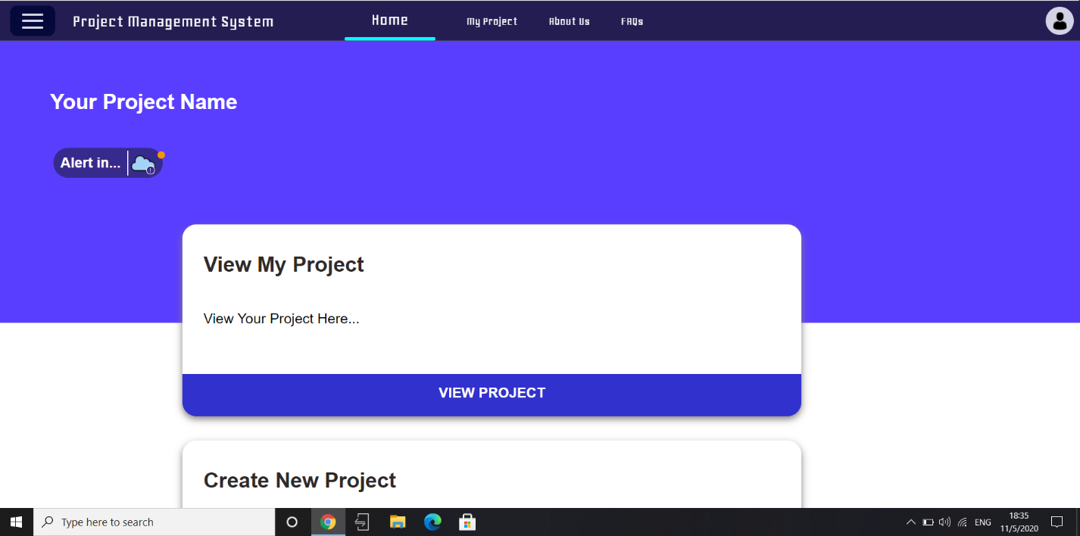

**7.1.10 View Project:**

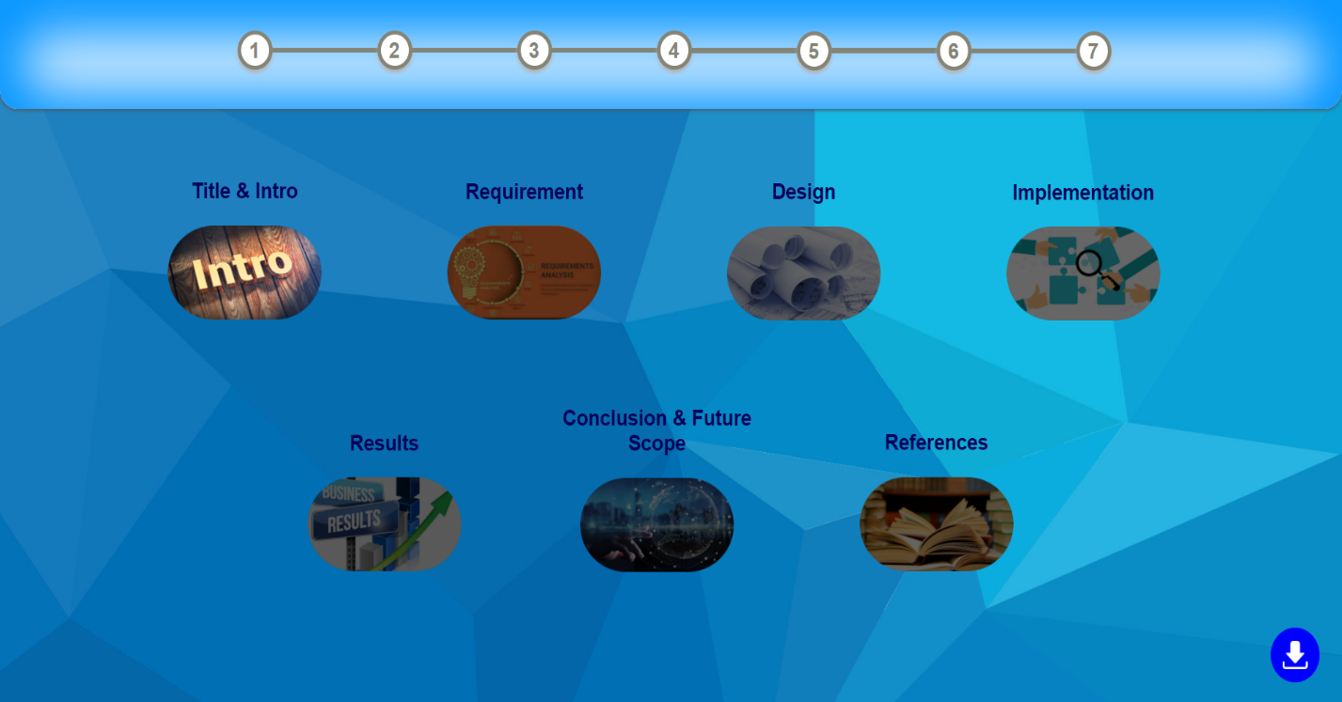

**7.1.11 Upload Project:**

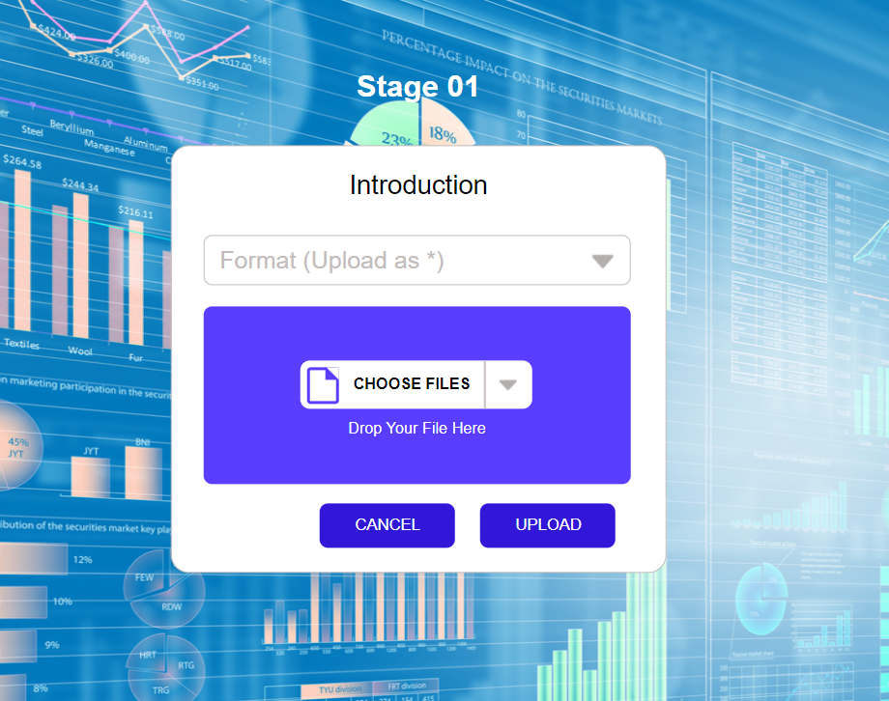

**7.1.12 MyProject:**

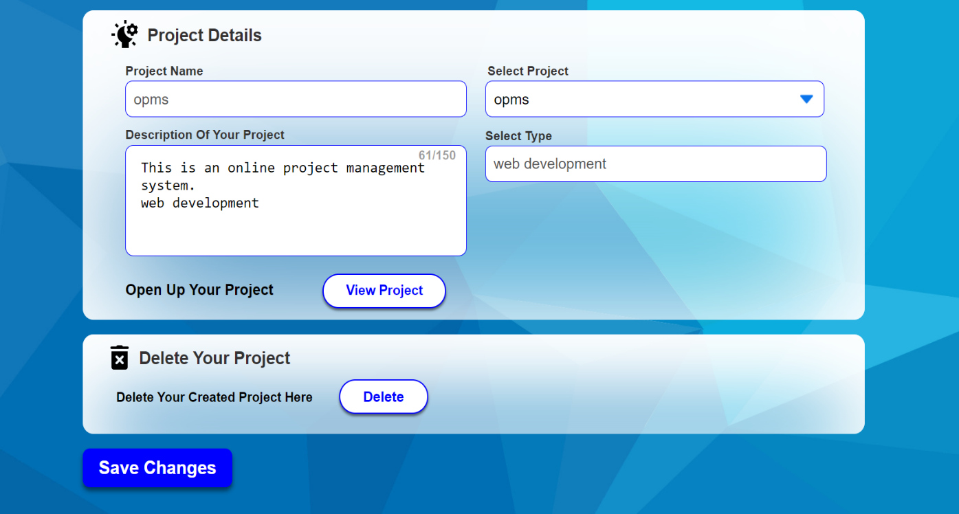

**7.1.13 About Us:**

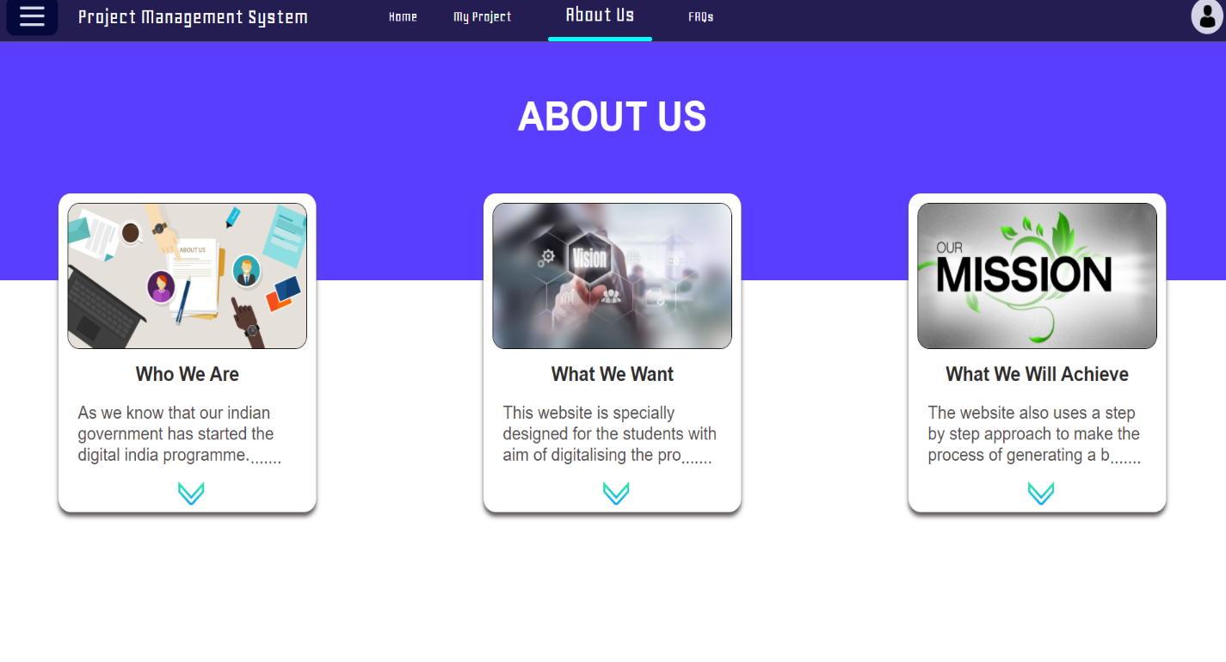

**7.1.14 FAQ’s:**

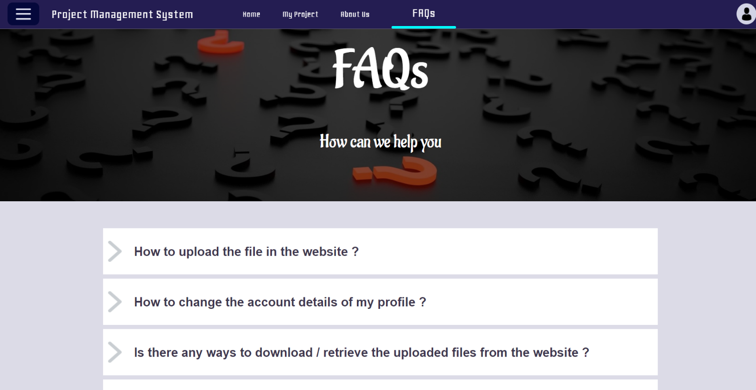

**7.1.15 Teacher Module:**

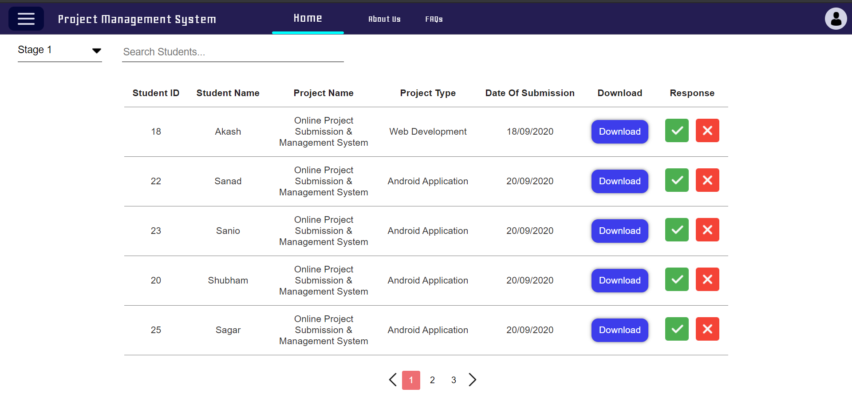

**7.1.16 ProjectList:**

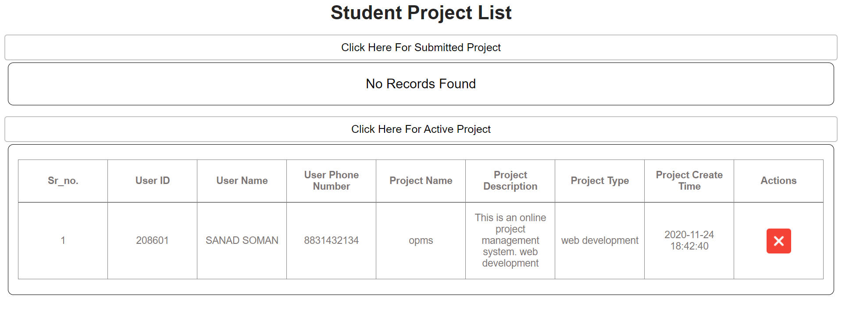

**Chapter 8: Conclusion**

* + - Online Project Management System will facilitate students to upload their files from anywhere and anytime.
    - Online project Management System automatically divides students into groups assigns them a unique group id based on number of teachers.
    - Online Project Management System provides stages for uploading files.

**Chapter 9: Bibliography**

* + - <https://stackoverflow.com/>
    - <https://getbootstrap.com/>
    - <https://code.jquery.com/jquery-3.5.1.min.js>
    - www.w3schools.com